Humanities 12 Fisher

a Few, Common Problms that Effect student Writing;
(and how's to Fix it)

Contractions
No contractions in formal writing, EVER. This is when you combine two words by taking out some letters and glue them together with Satan's favorite punctuator: the apostrophe. (Don't, won't, can't, etc) This will never change. Never ever. Contractions are to formal writing what Jar Jar Binks was to Star Wars Episode I: The Phantom Menace. It will be this way until you die, which will happen to you very soon if you continue to use contractions in your formal writing, so get over them and live long.
- Find apostrophe help with a sense of humor here: http://theoatmeal.com/comics/apostrophe

Semicolons
Reading student essays can sometimes feel like a semicolonoscopy. This tricky bit of punctuation is for combining two independent clauses, which is something you should not do that often to begin with. Semicolons are a lot like watching a bear ride a bicycle: rare and beautiful when executed properly, but if you come across it too often something may be seriously wrong. A rule to live by: if you are using more than one semicolon per page, you have issues.
- See “The Oatmeal” for some great semicolonology: http://theoatmeal.com/comics/semicolon

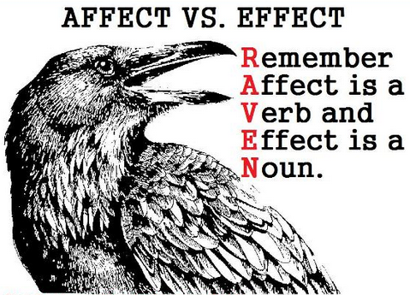
Affect and Effect
Affect is a verb, effect is a noun. There are exceptions to this of course, but whatever – just stick to basics for now. Overly concerned, or dying to know more? Google “affect versus effect” and allow the internet to berate you. Really brave? Try Youtube.
- Now practice: http://english.clas.asu.edu/files/shared/enged/AffectvsEffect.pdf

Citing Sources
Seriously, you have to cite them throughout your paper. Citations help readers understand the thoughtfulness and context of your argument, credit research and ideas that are not yours, give your thoughts and ideas a sense of legitimacy, and demonstrate your integrity. And because reading research papers with no evidence is a lot like beating yourself over the head with a porcupine.
- Go here for a great writeup: http://library.albany.edu/usered/cite/citing.html
- See also: http://owl.english.purdue.edu/owl/resource/747/01/

Topic Sentences
Do not let Topic Sentences be the equatorial trench on your Death Star. How do we write them? What is the purpose of these anyway? Why do we need them and in what ways do they benefit argumentative writing? Here are some resources that can get you on track. Re-write one of your old grungy ones and show it off!
- http://owl.english.purdue.edu/engagement/index.php?category_id=2&sub_category_id=1&article_id=29
- http://owl.english.purdue.edu/engagement/index.php?category_id=2&sub_category_id=2&article_id=57
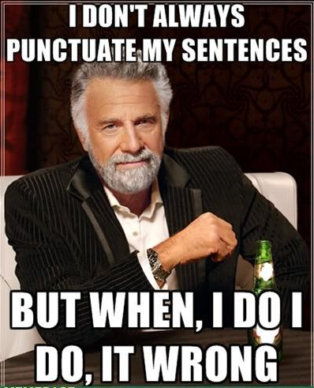
Paragraphing
Are your paragraphs too long, too short? Do they contain more than one main idea? Do you struggle finding the right places to split them up? Check out this OWL resource and use it to tighten up your paragraph structure. (Stuck? Don't forget your TEAs)
- Paragraphs: http://owl.english.purdue.edu/owl/resource/606/01/

Comma Usage
Commas are what ninjas use when they write because punctuation should be fast, precise, and deadly. Although there are oodles of ways to use them, there are more wrong ways than right ones. Not knowing how to use commas properly is a fast way to a C Minus. Those of you who struggle with comma usage (you know who you are...) fear not: There are some excellent online resources to help you sort out these comma-n mistakes.
- Take the comma quiz: http://www.towson.edu/ows/exercisecomma2.htm
- Ur doin it rong: http://www.howstuffworks.com/10-wrong-ways-to-use-commas.htm#page=5
- More mistakes: http://opinionator.blogs.nytimes.com/2012/05/21/the-most-comma-mistakes/
- How to do it right: http://grammar.quickanddirtytips.com/where-do-i-use-commas.aspx

Use your formal voice!
Would you show up to prom wearing your dad's extra-short cut-off jean shorts? Mom's bra on your head? This is what you are doing when you do not write an essay using your formal voice. There are seven simple rules to follow. Know them, use them, love them. Keep it classy, and don't be that guy (or gal). Go here for the 7 Deadly Ins, and a cool video:
- Seven Rules: http://www2.ivcc.edu/rambo/tip_formal_writing_voice.htm

